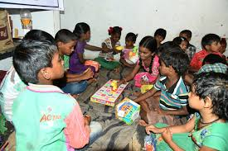

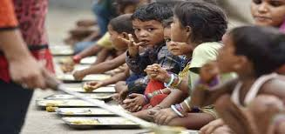



A little about us

**Lion Lives is a non-profit organization. We help needy people through our charity website.We try to give a small helping hand to the ones who actually deserve. We believe in ,If you have Proper Message and Perfect plan to Spend that Money that its what you can get more Charity from your End.**